# Third Party Services

To provide to the user the best experience possible, in our app we use third party services that make TeamMate both efficient and easier to develop. Those services are:

## Google Play Services

### Google Account Login

We use Google’s account login services to manage the users that log in to the application.

### Google Location

This library is used to provide the location to the app in order to perform the core functionality of the app, get sports venues and activities based on the location of the device.

Next, we will show a simple diagram of how our application is connected to Google’s services.

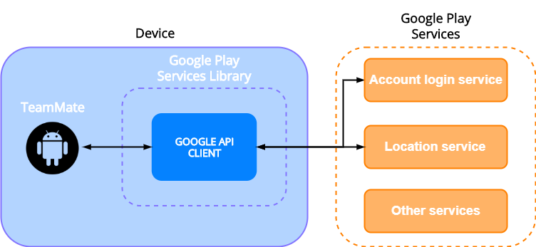

## Firebase Cloud Firestore

Our database is Firebase Cloud Firestore. We chose this database because it has a really complete set of features such as ads, analytics, push notifications, full document storage and many more; the entire database is backed by a real-time connection to the back end, enabling us to watch for live updates in the application and reducing the number of queries significantly. Also, Cloud Firestore performance is excellent; queries are performed extremely fast in almost all kind of connection speeds.

Next, we will show a simple diagram.

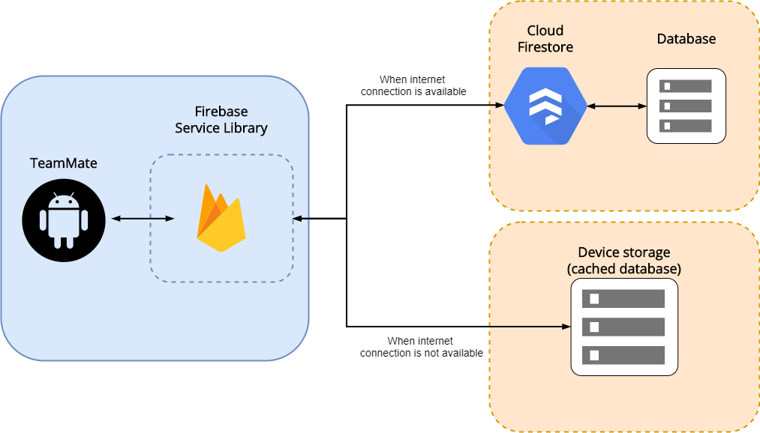

## Google Places SDK

We use *Places SDK* to get the nearby sport venues that are nearby the device that is running TeamMate. In order to achieve this, we need other libraries and APIs. These are:

### Volley

Volley is an HTTP library that makes networking for Android apps. Used to build and send the HTTP query for *Places SDK*.

### Gson

Gson is a Java library that can be used to convert a *JSON* string to an equivalent *Java* object and vice versa. We use this to handle *Places SDK* HTTP response.

Next, we will show a simple diagram.

